
PQI USB Single Slot Flash Card Reader/Writer User Manual

Thanks for choosing PQI USB Flash Card Reader/Writer. Please read carefully this User Manual before you start to use the Card Reader/Writer.

- How to use the Card Reader/Writer in Windows 98/98SE?
In Windows 98/98SE, you need to install the driver then you can use the card reader/writer. Please insert the CD into your CD-ROM, then you will have the screen as the following. Please choose the Flash Card Reader/Writer you buy then click the button. The driver will be installed automatically. If you need to uninstall the driver, just run the above process again.
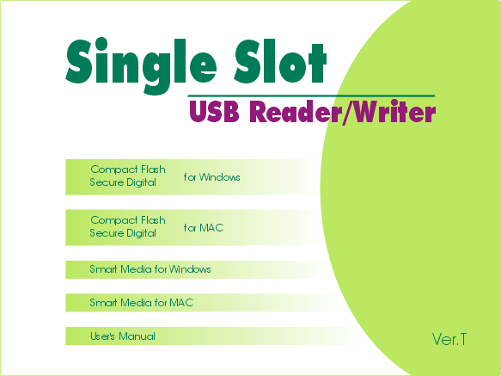

If the card reader/writer you buy is without built-in flash disk, you will have 1 extra icon in the “File Manager” of your computer as the following.

If the card reader/writer you buy is with built-in flash disk, you will have 2 extra icons in the “File Manager” of your computer as the following picture.
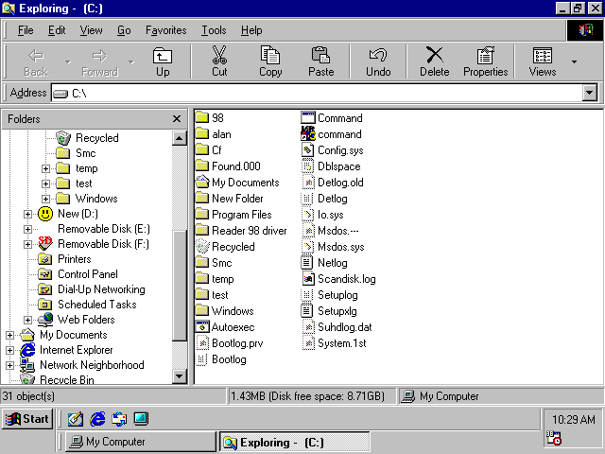
* If the model you buy is Smart Media Card Reader/Writer with built-in flash disk, you still only have 1 extra icon in the “File Manager” of your computer. The built-in flash disk is only workable when the Smart Media Card is not in the slot.

- How to use the Card Reader/Writer in Windows 2000?
If the card reader/writer you buy is without built-in flash disk, you don’t need to install any driver. Please plug the card reader/writer into the USB port then you can use it.
If the card reader/writer you buy is with built-in flash disk, please insert the CD into your CD-ROM, then you will have the screen as the following. Please choose the Flash Card Reader/Writer you buy then click the button. The driver will be installed automatically. If you need to uninstall the driver, just run the above process again.

If the card reader/writer you buy is without built-in flash disk, you will have 1 extra icon in the “File Manager” of your computer as following.
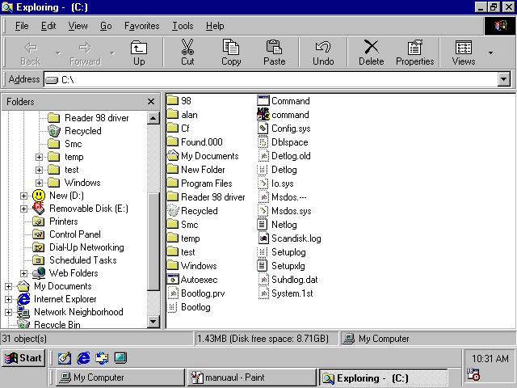
If the card reader/writer you buy is with built-in flash disk, you will have 2 extra icons in the “File Manager” of your computer as the following picture.

* If the model you buy is Smart Media Card Reader/Writer with built-in flash disk, you still only have 1 extra icon in the “File Manager” of your computer. The built-in flash disk is only workable when the Smart Media Card is not in the slot.

- How to use the Card Reader/Writer in Windows ME & XP?
You don’t need to install any driver. Please plug the card reader/writer into the USB port then you can use it.

If the card reader/writer you buy is without built-in flash disk, you will have 1 extra icon in the “File Manager” of your computer.
If the card reader/writer you buy is with built-in flash disk, you will have 2 extra icons in the “File Manager” of your computer as the following picture.
* If the model you buy is Smart Media Card Reader/Writer with built-in flash disk, you still only have 1 extra icon in the “File Manager” of your computer. The built-in flash disk is only workable when the Smart Media Card is not in the slot.

- How to use the Card Reader/Writer in Mac O/S?
Due to the Mac driver is not ready yet, we provide you an alternative to use our card reader/writer. If you want to use the flash card reader/writer with your Mac, please insert your flash card into the card reader/writer first then plug the card reader/writer into the USB port. Your Mac will recognize an “untitled” HDD icon then you can use your card reader/writer. If you want to use the built-in flash disk, just don’t insert any flash card into the card reader/writer, then plug the card reader/writer into the USB port. Your Mac will recognize an “untitled” HDD then you can use the built-in flash disk.
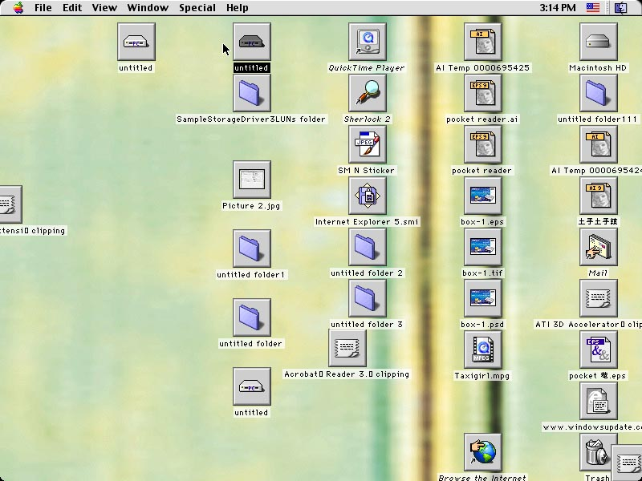
The Mac driver is developing now, please visit our website to download the update Mac Driver: www.pqi.com.tw

Remark:
If you cannot access the driver from your CD, please download the update driver from our website: www.pqi.com.tw .

